Lab: JS Basic Syntax, Conditional Statements, and Loops
Submit your solutions in the SoftUni judge system at: https://alpha.judge.softuni.org/contests/basic-syntax-conditional-statements-and-loops-lab/1189

Multiply Number by 2
Write a function that receives a number and prints as result that number multiplied by two.

Examples
Input | Output
2 | 4
5 | 10
20 | 40

Hints
Create a function called solve (or some other name). As parameters, it will receive a number num.
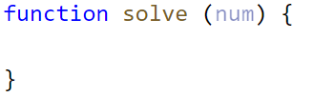
Print the result inside the function.
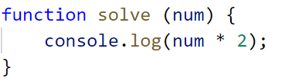
If you want to test your code locally, you need to call the function.
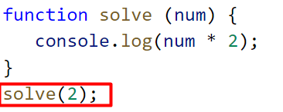

Student Information
You will be given 3 parameters – student name (string), age (number), and average grade (number). Your task is to print all the info about the student in the following format:
`Name: {student name}, Age: {student age}, Grade: {student grade}`
Note: The grade should be formatted to the second decimal point.

Examples
Input | Output
'John', 15, 5.54678 | Name: John, Age: 15, Grade: 5.55
'Steve', 16, 2.1426 | Name: Steve, Age: 16, Grade: 2.14
'Marry', 12, 6.00 | Name: Marry, Age: 12, Grade: 6.00

Hint
Use toFixed() method to format the grade.
- First, receive the input:
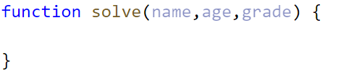
- Print the output:

Excellent Grade
Write a function that receives a single number and checks if the grade is excellent or not.
If it is, print "Excellent", otherwise print "Not excellent".

Examples
Input | Output
5.50 | Excellent
4.35 | Not excellent

Hints
Check if the number given is greater or equal to 5.50 and print the corresponding result.
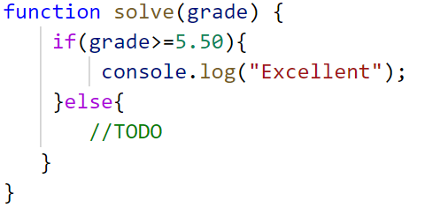

Foreign Languages
Write a program, which prints the language, that a given country speaks. You can receive only the following combinations:
- English is spoken in England and USA;
- Spanish is spoken in Spain, Argentina, and Mexico;
- For the others, we should print "unknown";

Input
You will receive a single country name.

Output
Print the language, which the country speaks, or if it is unknown for your program, print "unknown".

Examples
Input | Output |  | Input | Output
USA | English |  | Germany | unknown

Hint
Think about how you can merge multiple cases, to avoid writing more code than you need to.

Month Printer
Write a program, that takes an integer as a parameter and prints the corresponding month. If the number is more than 12 or less than 1 print "Error!"

Input
You will receive a single number.

Output
If the number is within the boundaries print the corresponding month, otherwise print "Error!"

Examples
Input | Output |  | Input | Output
2 | February |  | 13 | Error!

Theatre Promotions
A theatre is doing a ticket sale, but they need a program to calculate the price of a single ticket. If the given age does not fit one of the categories, you should print "Error!". You can see the prices in the table below:
Day / Age | 0 <= age <= 18 | 18 < age <= 64 | 64 < age <= 122
Weekday | 12$ | 18$ | 12$
Weekend | 15$ | 20$ | 15$
Holiday | 5$ | 12$ | 10$

Input
The input comes in two parameters. The first one will be the type of day (string). The second – the age of the person (number).

Output
Print the price of the ticket according to the table, or "Error!" if the age is not in the table.

Constraints
- The age will be in the interval [-1000…1000].
- The type of day will always be valid.

Examples
Input | Output |  | Input | Output |  | Input | Output
'Weekday',  42 | 18$ |  | 'Holiday', -12 | Error! |  | 'Holiday', 15 | 5$

Numbers from 1 to 5
Write a function that prints all the numbers from 1 to 5 (inclusive) each on a separate line.

Hints
Create a for loop starting from 1 and continuing until 5 and print the number.
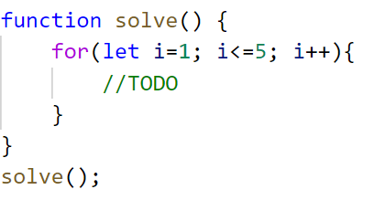

Divisible by 3
Write a program, which prints all the numbers from 1 to 100, which are divisible by 3. You have to use a single for loop. The program should not receive input.

Numbers from N to 1
Write a function that receives a number N and prints all the numbers from N to 1. Try using the while loop.

Examples
Input | Output
5 | 5  4  3  2  1
3 | 3  2  1

Hints
Create a while loop with condition N >= 1. Print N and decrease it with each step.
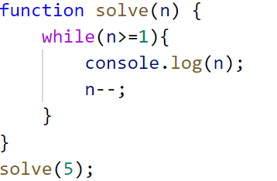

Numbers from M to N
Write a function that receives a number M and a number N (M will always be bigger than N). Print all numbers from M to N.

Examples
Input | Output
6, 2 | 6  5  4  3  2
4, 1 | 4  3  2  1

Hints
Use for or while loop and print the numbers.
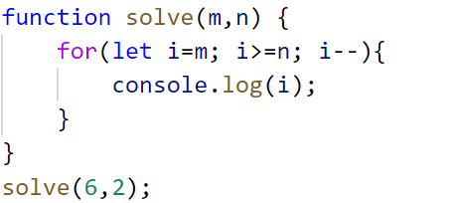

Sum of Odd Numbers
Write a program that prints the next n odd numbers (starting from 1) and on the last row prints the sum of them.

Input
You will receive a number – n. This number shows how many odd numbers you should print.

Output
Print the next n odd numbers, starting from 1, separated by newlines.
On the last line, print the sum of these numbers in the following format: `Sum: {total sum}`.

Constraints
- n will be in the interval [1…100]

Examples
Input | Output |  | Input | Output
5 | 1  3  5  7  9  Sum: 25 |  | 3 | 1  3  5  Sum: 9

